**Termwork 1**

**Name: Shradha Mallikarjun Patil**

**USN: 2GI20CS144**

**Output:**

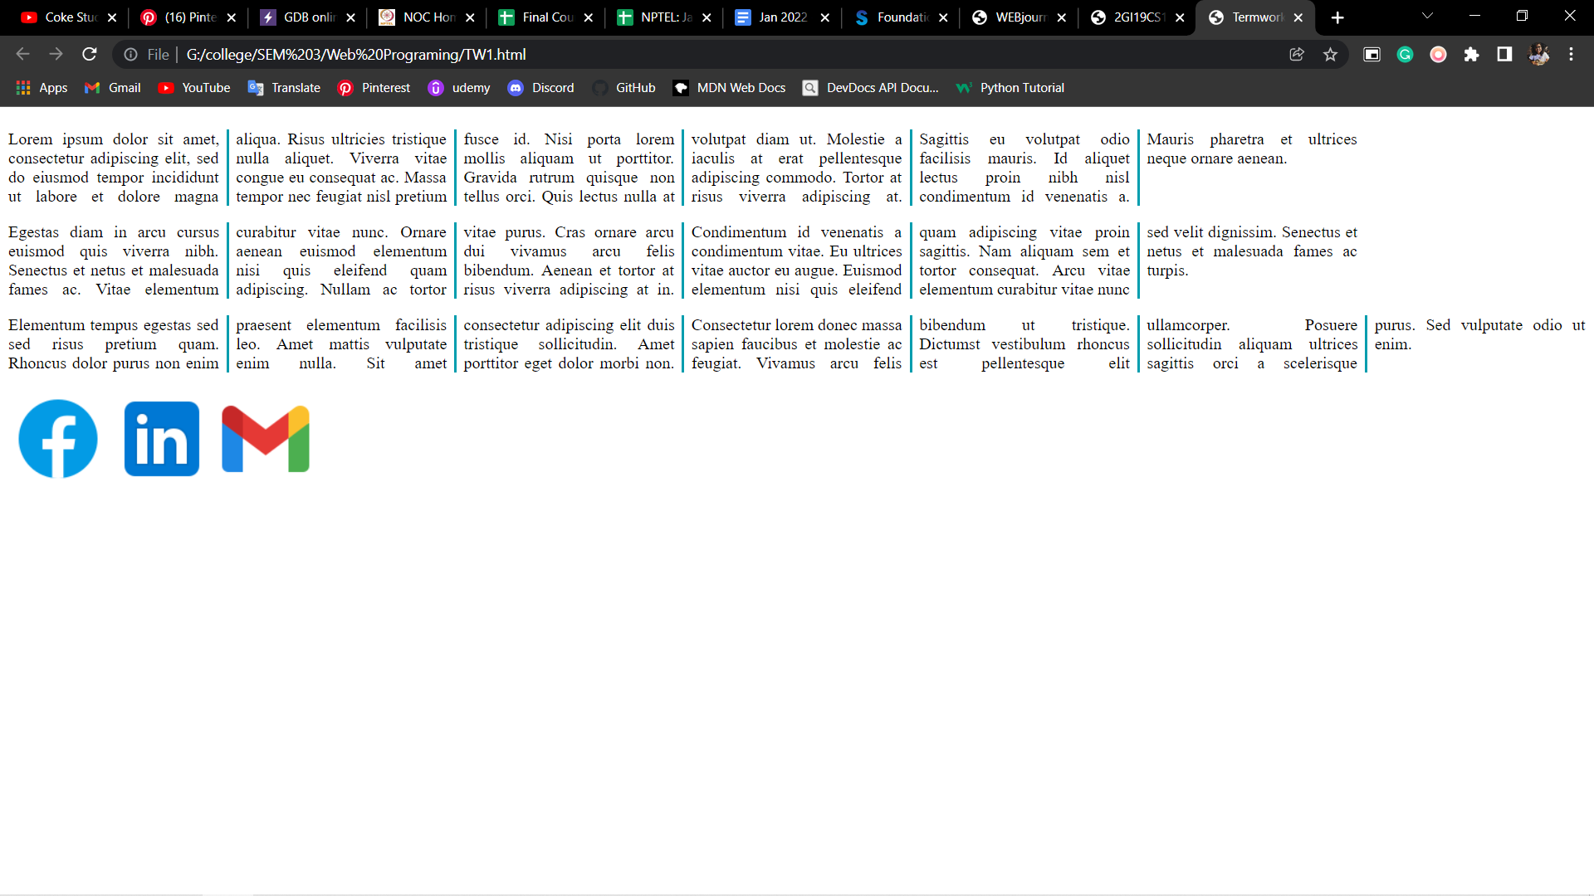

**Termwork 2**

**Name: Shradha Mallikarjun Patil**

**USN: 2GI20CS144**

**Output:**

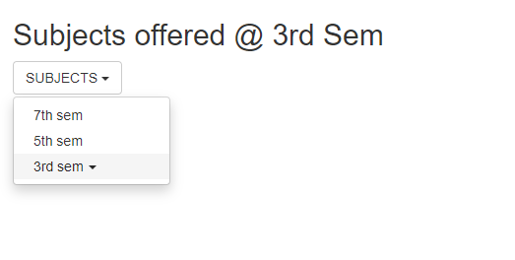

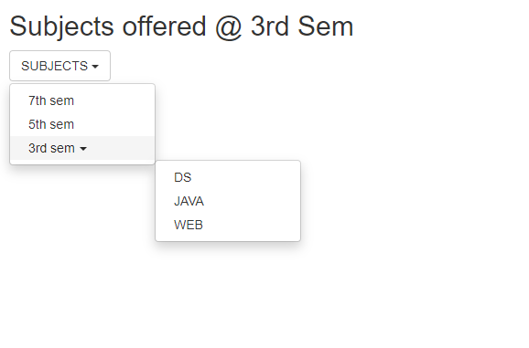

**Termwork 3**

**Name: Shradha Mallikarjun Patil**

**USN: 2GI20CS144**

**Output:**

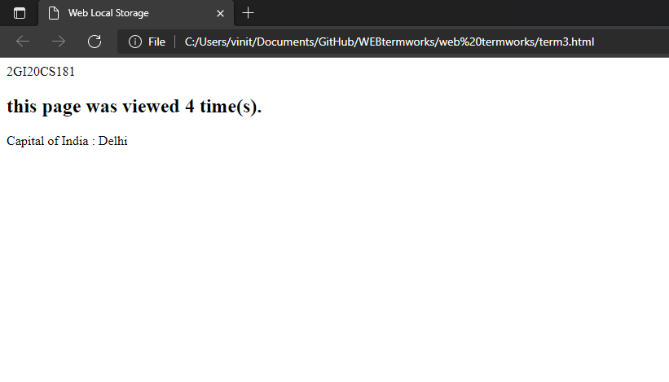

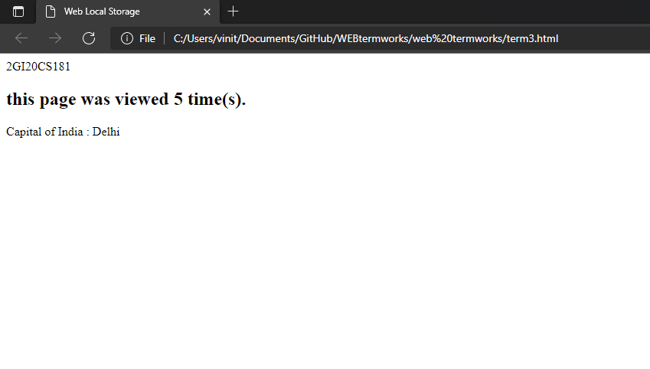

**Termwork 4**

**Name: Shradha Mallikarjun Patil**

**USN: 2GI20CS144**

**Output:**

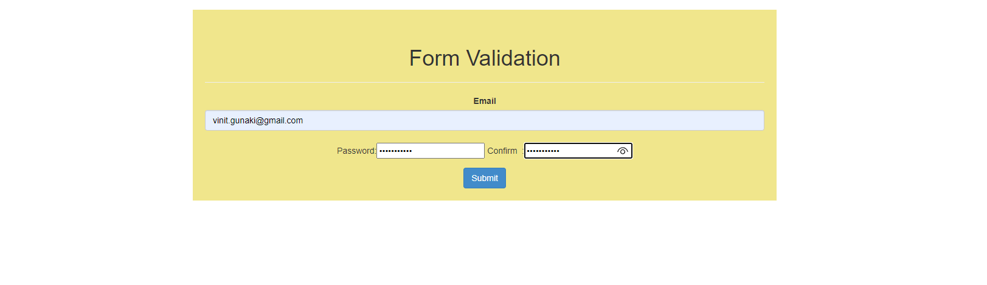

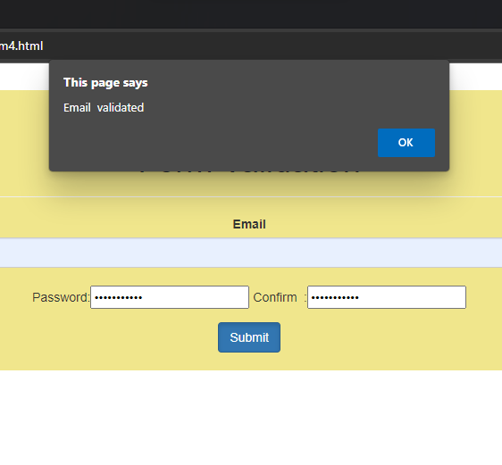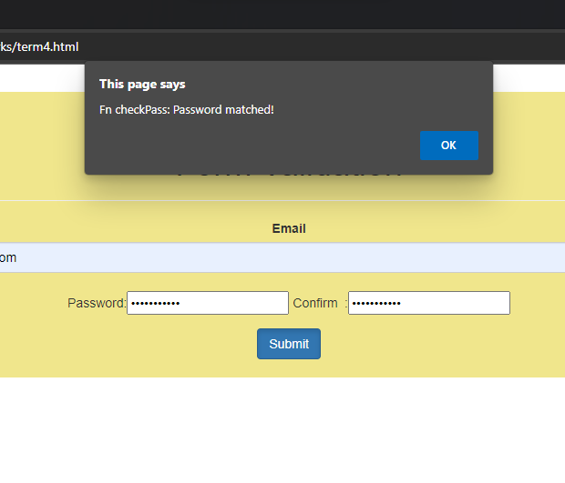

**Termwork 6**

**Name: Shradha Mallikarjun Patil**

**USN: 2GI20CS144**

**Output:**

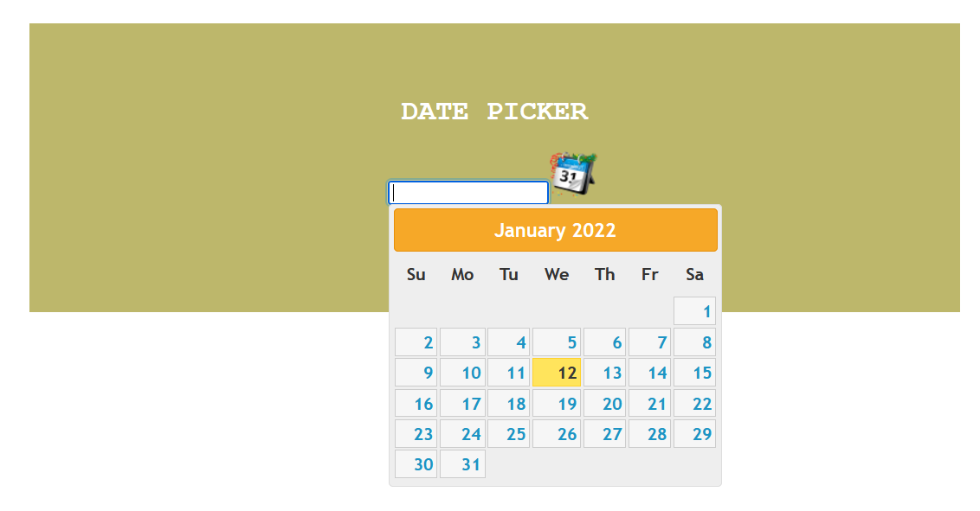

**Termwork 7**

**Name: Shradha Mallikarjun Patil**

**USN: 2GI20CS144**

**Output:**

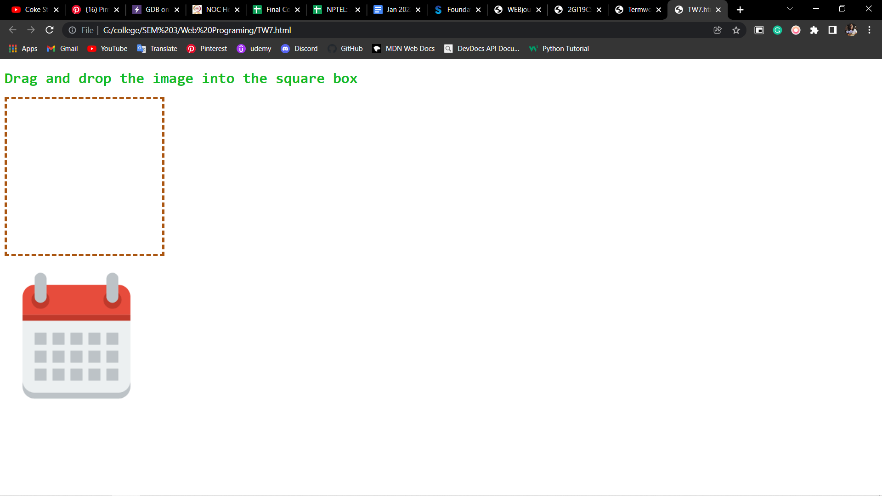

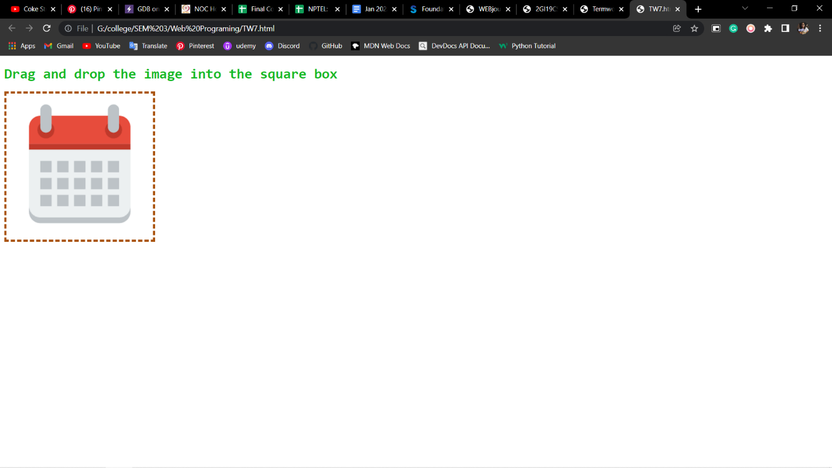

**Termwork 8**

**Name: Shradha Mallikarjun Patil**

**USN: 2GI20CS144**

**Output:**

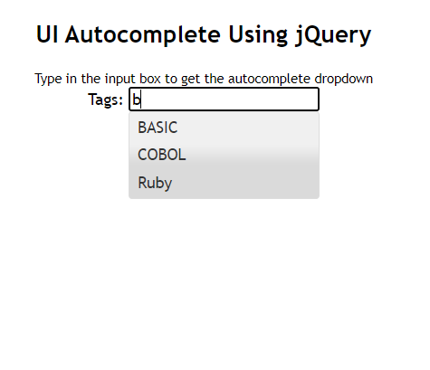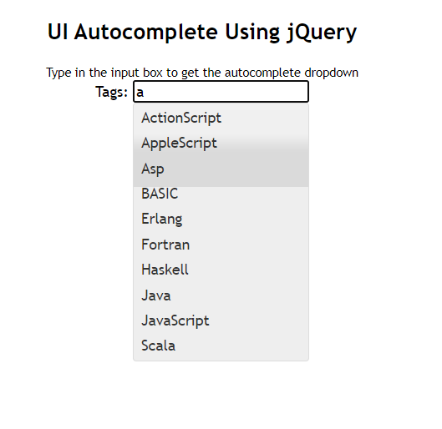

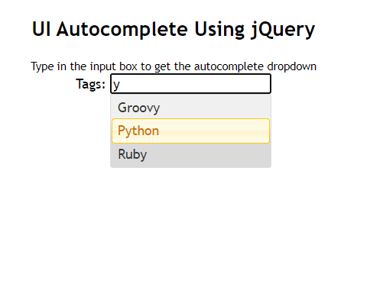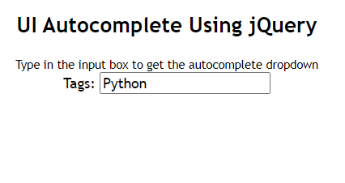

**Termwork 5**

**Name: Shradha Mallikarjun Patil**

**USN: 2GI20CS144**

**Output:**

